**Ideation Phase Problem Statement**

|  |  |
| --- | --- |
| Date | 25 September 2022 |
| Team ID | PNT2022TMID40555 |
| Project Name | **AI-Powered Nutrition Analyzer For Fitness Enthusiasts** |
| Maximum Marks | 2 Marks |

**Problem Statement**

In day-to-today life, either insufficient or plentiful intake of nutrients results in nutritional imbalance in our health leading to various diseases.In India, because of unhealthy food, most young people are dying due to obesity, type 2 diabetes, heart disease, high blood pressure, and stroke. Nutritional Analysis ensures that the food has optimal requirement of vitamins and minerals wherein the examining of nutrition in food helps in understanding about the fat proportion, carbohydrates dilution, proteins, fiber, sugar, etc.The main aim of the project is to building a model which is used for classifying the fruit depending on different characteristics like colour, shape, texture etc. Here,the user can capture the images of different fruits and then the image will be sent to the trained model. The model analyses it and detect the nutrition based on the fruits like Sugar, Fibre, Protein, Calories, etc..

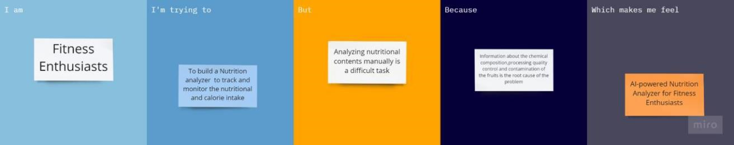

|  |  |  |  |  |  |
| --- | --- | --- | --- | --- | --- |
| **Problem Statement (PS)** | **I am**  **(Customer)** | **I’m trying to** | **But** | **Because** | **Which makes me feel** |
| PS-1 | Fitness | Build a | Analyzing | Information | AI-powered Nutrition |
|  | enthusiasts | nutrition | nutritional | about the | Analyzer for Fitness |
|  |  | analyzer | contents | chemical | Enthusiasts |
|  |  |  | manually is | composition, |  |
|  |  |  | a difficult | processing |  |
|  |  |  | task | quality control and contaminatio n of the fruits is the root cause of the problem |  |